System Requirements Statement (SRS) –

Order My Cake

Doc. Ref. :

Version : 0.4

Status : Drafted

Created by : Order my cake team(grp 3)

Date : 15-03-2023

1. Introduction 3

2. Functional Requirements 4

2.1 Customer Module 5

2.2 Vendor Module 9

2.3 Admin Module 13

2.4 Corporate Customer Module…………………………………………………………...15

2.4 Use Case Diagram.............................................................................................................................19

THIS DOCUMENT CONTAINS 22 NUMBERED PAGES

# Introduction

This document is the SRS report for Order My Cake.

Order My Cake System could divide the four main parts Customer Module, Admin Module, Vendor Module, Corporate-customer Module.

The Order My Cake is an application that will help in maintaining the sales activity in the cake’s shops.

# Functional Requirements

The Account part of Order My Cake System has four modules which are divided 13 processes described as below.

|  |  |  |
| --- | --- | --- |
| **No** | **BRS requirement ID** | **Description** |
| **2.1** | **Customer Module** | |
| **2.1.1** | **F1** | **Account Creation Process** |
| **2.1.2** | **F2** | **Login Process** |
| **2.1.3** | **F3** | **View Products** |
| **2.1.4** | **F4** | **Order Products** |
| **2.1.5** | **F5** | **Make payment** |
| **2.1.6** | **F6** | **Cancel Order** |
| **2.1.7** | **F7** | **Product Feedback** |
| **2.1.8** | **F8** | **Forgot Password Process** |
| **2.1.9** | **F9** | **Change Password Process** |
| **2.1.10** | **F10** | **Logout Process** |
| **­2.2 Vendor Module** | | |
| **2.2.1** | **F11** | **Account Creation Process** |
| **2.2.2** | **F12** | **Login Process** |
| **2.2.3** | **F13** | **Add Products** |
| **2.2.4** | **F14** | **Add Offers** |
| **2.2.5** | **F15** | **View Order placed by Customer** |
| **2.2.6** | **F16** | **Order Confirmation For Buyer** |
| **2.2.7** | **F17** | **View Requirements from Corporate Customer** |
| **2.2.8** | **F18** | **Respond the Corporate Customer** |
| **2.2.9** | **F19** | **Remove Products** |
| **2.2.10** | **F20** | **Can view the Feedback** |
| **2.2.11** | **F21** | **Forgot Password Process** |
| **2.2.12** | **F22** | **Change Password Process** |
| **2.2.13** | **F23** | **Logout Process** |
| **2.3 Admin Module** | | |
| **2.3.1** | **F24** | **Login Process** |
| **2.3.2** | **F25** | **Approval of Vendor-registration** |
| **2.3.3** | **F26** | **Add or update different Flavour** |
| **2.3.4** | **F27** | **Generate Sales Report for particular time period** |
| **2.3.5** | **F28** | **View the Feedback** |
| **2.4 Corporate Module** | | |
| **2.4.1** | **F30** | **Account Creation Process** |
| **2.4.2** | **F31** | **Login Process** |
| **2.4.3** | **F32** | **Request for bulk order** |
| **2.4.4** | **F33** | **View Response from different Vendors** |
| **2.4.5** | **F34** | **Order Confirmation** |
| **2.4.6** | **F35** | **Make payment** |
| **2.4.7** | **F36** | **Forgot Password Process** |
| **2.4.8** | **F37** | **Change Password Process** |
| **2.4.9** | **F38** | **Logout Process** |

## Customer Module

* Customer is the user of system who wants to buy the product.

* He is also able to view the products, search the product and buy the product.

### Account Creation Process

* Order My Cake System compels to create the account before using it. So, Order My Cake System should provide the function which makes customer creates new account.
* When customer creates new account, the function demands following information described as below.

1. Login information
2. Contact Details

* The Login information

The Login information consists of some items described as below.

1. Customer ID
2. Name
3. DOB
4. E-mail
5. Mobile Number
6. Password
7. Address
   * All items are compulsory demanded.
   * Customer ID

* The Customer ID should be unique. If the Customer ID correspond with not case-sensitive to other which is previously registered, the Customer ID should not be registered as an account.
  + Password
* The Password has constraints which makes the Password consists of more than or equal 8 and less than or equal 12 characteristics including characters described as below.

1. Numeric figure (at least one)
2. Capital alphabet (A-Z) (at least one)
3. Small alphabet (a-z) (at least one)
4. Special character (#, $, %, &, etc.) (at least one)

* The Password is masked by dummy characters. The re-entering Password is demanded.
* The Password must be encrypted in Order My Cake System.
  + User Type

The User Type falls into four categories described as below.

1. Customer
2. Cake-Vendor
3. Administrator
4. Corporate-Customer

* In an Account Creation Process, the user can select customer, Cake-vendor or corporate customer.
* No one could select The Administrator, because Administrator is implemented to Order My Cake System in advance.
* Contact Details

The Contact Detail consists of some items described as below.

1. Permanent Address
2. Contact Phone No
   * All items are compulsory demanded.
   * Permanent Address

* Permanent Address should be filled.
* But only the state should be selected from options.
* The Security Question information

The Security Question information is needed when Customer lost their Password. This information consists of two items described as below.

1. Selected Question
2. Answer
   * All items are compulsory demanded.
   * Some questions which are difficult to answer for anyone else are prepared in advance.

E.g which is your favorite cake?

* + A question should be selected from options by the Customer, and the Answer is registered by the Customer.
* Login information should be entered on one screen, and then Customer information and Security Question information should be entered on another screen.

### Login Process

* Order My Cake System always compels user authentication before using itself except when a new account is successfully created.
* The user authentication demands Email and Password. The Email and the Password should be checked in two ways.
  + First, The Email and the Password should be existed and correct.
* If The Email and the Password are not equal to what the user has registered, the user authentication cannot be provided.
  + Second, the User Type linked to the Customer ID should be "Customer".
* When the User Type is "Customer", then user can be placed on “Customer Home”.
* Only when the two checks are successfully completed, Customer can be placed on respected page.
* The “Customer Home” provides the items described as below.

1. A trigger to Search Product
2. A trigger to logout
3. A trigger to update Account
4. A trigger to Change Password
5. A trigger to Delete Product

### 2.1.3 View Product

* Customer can View products are described as below.

1. Product category

* Flavor

Customer can view the cakes based on flavors .

1. Price range

* From Highest price-Lowest price
* From Lowest price-Highest price

1. Near by Locality

* Select the area

### 2.1.4 Order Product

* System will allow customer to place order for particular product.
* The order will be available for customer till the customer.

### 2.1.5 Make Payment

* In this system we are dealing the mode of payment by Cash.
* We will extend this to Credit card, debit card etc. in the future.

### 2.1.6 Cancel Order

* System will provide facility for customer to cancel order after the conformation.

### 2.1.7 Product Feedback

* Customer can give feedback to the products that he/she have ordered.
* Customer can give rating to the products he has been order or delivered .he can give rating in the star format which represent the quality and services provided .

### 2.1.8 Forgot Password Process

* When system user lost their Password, the recovery method should be provided by Order My Cake system.

The recovery method is described as below.

* + First, system user enters their email-id .
  + Next, Order My Cake System demands the Answer which has been registered since when the Account was created.
  + Only when the Answer is correct, customer get the new password by E-mail which also has been registered since when the Account was created.
  + Second, if answer is valid then he/she can enter the new password.
* Of course, the new password should consist of more than or equal 8 and less than or equal 12 characteristics including at least a numeric figure, a capital alphabet, a small alphabet, and a special character.
* Then, the Customer had better change the new password manually.

### 2.1.9 Change Password Process

* When Customer wants to change their Password, the measure should be provided by the System.
* Therefore, Order My Cake System should provide the function which is available after getting the Customer authentication.
* The function demands the current password and the new password.
  + Of course, the new password should consist of more than or equal 8 and less than or equal 16 characteristics including at least a numeric figure, a capital alphabet, a small alphabet, and a special character.
  + The current password and the new password are masked by using dummy characters.
  + The new password is demanded to enter twice to avoid a typing error.
* Only when the current password is correct, Customer could change their Password.
* When the current password is changed into new password, Order My Cake System compels user authentication again.

### 2.1.10 Logout Process

* After successfully ordering or surfing for the product customer can logout.

## Cake-Vendor Module

### 2.2.1 Account Creation Process

* Order My Cake System compels to create the account before using it. So, Order My Cake System should provide the function which makes Vendor creates new account.
* When Cake-Vendor creates new account, the function demands following information described as below.

1. Login information

2.Contact Details

* The Login information

The Login information consists of some items described as below.

1. 1.Vendor ID
2. 2.Password
3. 3.Name of the cake shop
4. License number.
5. 4.E-mail address
6. 5.Full Address of the cake Shop
   * All items are compulsory demanded.
   * Vendor ID

* The Vendor ID should be unique. If the Vendor ID correspond with not case-sensitive to other which is previously registered, the Vendor ID should not be registered as an account.
  + Password
* The Password has constraints which makes the Password consists of more than or equal 8 and less than or equal 12 characteristics including characters described as below.

1.Numeric figure (at least one)

2.Capital alphabet (A-Z) (at least one)

3.Small alphabet (a-z) (at least one)

4.Special character (#, $, %, &, etc.) (at least one)

* The Password is masked by dummy characters. The re-entering Password is demanded.
* The Password must be encrypted in Order My Cake System.
* Contact Details

The Contact Detail consists of some items described as below.

1.Permanent Address

2.Contact Phone No

* + All items are compulsory demanded.
  + Permanent Address
* Permanent Address should be filled.
* But only the state should be selected from options.
* The Security Question information

The Security Question information is needed when Vendor lost their Password. This information consists of two items described as below.

1. Selected Question
2. Answer
   * All items are compulsory demanded.
   * Some questions which are difficult to answer for anyone else are prepared in advance.

E.g which is favorite cake?

* + A question should be selected from options by the Vendor, and the Answer is registered by the Vendor.
* Login information should be entered on one screen, and then Customer information and Security Question information should be entered on another screen.

### 2.2.2 Login Process

* Order My Cake System always compels Vendor authentication before using itself except when a new account is successfully created.
* The user authentication demands Email Id and Password. The Email Id and the Password should be checked in three ways.
  + First, The Email Id and the Password should be existed and correct.
* If The Email Id and the Password are not equal to what the user has registered, the user authentication cannot be provided.
  + Second, the User Type linked to the Vendor ID should be "user".
* When the User Type is " Vendor ", user can be placed on “Cake-Vendor Home”.
  + Finally, Vendor ID should be available.
* The Administrator can decide whether the Vendor ID is available or suspended – Refer to the SRS of the Admin part.
* If user is rejected, user authentication is not provided for Vendor.
* The Cake-Vendor account should alive for so long as the duration decided by Admin.
* Only when the three checks are successfully completed, Vendor can be placed on respected page.
* The “Vendor Home” provides some items described as below.

1. A trigger to logout
2. A trigger to update Account
3. A trigger to Change Password
4. A trigger to Add Product
5. A trigger to Add Offers to the Product for sale
6. A trigger to Update Product Information
7. A trigger to Delete Product

### 2.2.3 Add Product

* Order My Cake System give the functionality to Add Product (Cake).
* Vendor can add Designs, Weight, price, flavor .
* Vendor can also add if the Cake is Egg or Egg-less.

### 2.2.4 Add Offers for products

* Order My Cake System gives the functionality to add offers for customer attraction.
* System also gives offers on different occasions.

### 2.2.5 View Order placed by Customer

* Order My Cake System gives the functionality to see the Order placed by the customer.
* Vendor can also see the payment method done by the customer.

### 2.2.6 Order Confirmation Process

* After Viewing the order placed by the customer, vendor can Confirm the order.

### 2.2.7 View Requirements from Corporate Customer

* Vendor can view the request given by the corporate customer.

### 2.2.8 Respond to Corporate Customer

* After Viewing the request, vendor fulfills the requirements and respond the corporate customer with the pricing.

### 2.2.9 Remove Product

* Vendor can remove the product according to the availability in the shop.

### 2.2.10 View Feedback

* Vendor can view the feedback of the products which is ordered by the customer.

### 2.2.11 Forgot Password Process

* When Vendor lost their Password, the recovery method should be provided by Order My Cake system.

The recovery method is described as below.

* + First, Vendor enters their Email Id in Order My Cake System.
  + Next, Order My Cake System demands the Answer which has been registered since when the Account was created.
  + Second, if the answer is valid then the vendor can enter the new password.

Of course, the new password should consist of more than or equal 8 and less than or equal 12 characteristics including at least a numeric figure, a capital alphabet, a small alphabet, and a special character.

* As a consequence, The Vendor could get the user authentication using the new password.
  + Then, the Vendor had better change the new password manually.
* If the Answer is not correct, otherwise, the correct Answer is demanded for user again.
  + In that case, Of course, Vendor couldn’t get the new password.

### 2.2.12 Change Password Process

* When Vendor wants to change their Password, the measure should be provided by Order My Cake System.
* Therefore, Order My Cake System should provide the function which is available after getting the Vendor authentication.
* The function demands the current password and the new password.
  + Of course, the new password should consist of more than or equal 8 and less than or equal 12 characteristics including at least a numeric figure, a capital alphabet, a small alphabet, and a special character.
  + The current password and the new password are masked by using dummy characters.
  + The new password is demanded to enter twice to avoid a typing error.
* Only when the current password is correct, Vendor could change their Password.
* When the current password is changed into new password, Order My Cake System compels Vendor authentication again.

### 2.2.13 Logout Process

* After successfully accepting the order from the customer vendor can logout.

#### 2.3 Admin Module

**•** Administratorshould be responsible for following activities**.**

### 2.3.1 Login Process

* Order My Cake System always compels user authentication.
* The user authentication demands Admin ID and Password. The Admin ID and the Password should be checked in two ways.
  + First, The Admin ID and the Password should be existed and correct.
  + Second, the User Type linked to the Admin ID should be "Admin".
* When the User Type is "Admin", user can be placed on “Admin Home”.
* The Admin account should alive for so long as the duration decided by Admin.
* Only when the two checks are successfully completed, Admin can be placed on respected page.
* The “Admin Home” provides the some items described as below.

1. A trigger to logout
2. A trigger to update Account
3. A trigger to Change Password
4. A trigger to Browse existing Market price

### 2.3.2 Update the Account Process

* Admin can update his name, email, contact number and password.

### 2.3.3 Approval of Vendor Registration

* Admin has the authority to approve requests coming from different vendor at the time of registration.
* Admin can even reject the request.
* Admin can enable or disable the accounts.

### 2.3.4 Add or Update different Flavour

* The Vendors has one thing in common that is flavor.
* Admin can add and update flavor.

### 2.3.5 Generate the Sales Report for Particular Time Period

* Order My Cake System has functionality of generating sales report for particular time period which are handled by Admin.

### 2.3.6 View the Feedback

* Admin can also view the feedback of all the different Vendors given by the customers.

## Corporate Customer Module

* Corporate Customer is the user of system who wants to buy the product in bulk quantity.

* He is also able to view the products, search the product and buy the product.

### Account Creation Process

* Order My Cake System compels to create the account before using it. So, Order My Cake System should provide the function which makes Corporate customer creates new account.
* When Corporate customer creates new account, the function demands three information described as below.

1.Login information of the company

2.Login information of the person who is handling corporate account.

3.Contact Details

* The Login information

The Login information consists of some items described as below.

4.Corporate Customer ID

5.Name of the Company.

6.Company Registration number

7.E-mail

8.Mobile Number

9.Password

10.Address

* + All items are compulsory demanded.
  + Corporate Customer ID
* The Customer ID should be unique. If the Corporate Customer ID correspond with not case-sensitive to other which is previously registered, the Customer ID should not be registered as an account.
  + Password
* The Password has constraints which makes the Password consists of more than or equal 8 and less than or equal 12 characteristics including characters described as below.

1. Numeric figure (at least one)
2. Capital alphabet (A-Z) (at least one)
3. Small alphabet (a-z) (at least one)
4. Special character (#, $, %, &, etc.) (at least one)

* The Password is masked by dummy characters. The re-entering Password is demanded.
* The Password must be encrypted in Order My Cake System.
* Contact Details

The Contact Detail consists of some items described as below.

1. Permanent Address
2. Contact Phone No
   * All items are compulsory demanded.
   * Permanent Address

* Permanent Address should be filled.
* But only the state should be selected from options.
* The Security Question information

The Security Question information is needed when Corporate Customer lost their Password. This information consists of two items described as below.

1. Selected Question
2. Answer
   * All items are compulsory demanded.
   * Some questions which are difficult to answer for anyone else are prepared in advance.

E.g. which color do you like most?

* + A question should be selected from options by the Corporate Customer, and the Answer is registered by the Corporate Customer.
* Login information should be entered on one screen, and then Corporate Customer information and Security Question information should be entered on another screen.

### Login Process

* Order My Cake System always compels user authentication before using itself except when a new account is successfully created.
* The user authentication demands Email and Password. The Email and the Password should be checked in two ways.
  + First, The Email and the Password should be existed and correct.
* If The Email and the Password are not equal to what the user has registered, the user authentication cannot be provided.
  + Second, the User Type linked to the Corporate Customer ID should be " Corporate Customer".
* When the User Type is " Corporate Customer", then user can be placed on “Corporate Customer Home”.
* Only when the two checks are successfully completed, Customer can be placed on respected page.
* The “Corporate Customer Home” provides the items described as below.

1. A trigger to Search Product
2. A trigger to logout
3. A trigger to Change Password
4. A trigger to Delete Product

### 2.4.3 Request for bulk order

* Corporate Customer can request to different vendors as per their requirements.
* The Request-order will be available for corporate customer.

### 2.4.4 Respond from different Vendor

* Corporate Customer can view responses from different Vendor.

### 2.4.5 Order Confirmation

* After viewing response from different vendor, Corporate Customer can select the specific vendor which they have fully agree as per the pricing.

### 2.4.6 Make Payment

* In this system we are dealing the mode of payment by Cash.
* We will extend this to Credit card, debit card etc. in the future.

### 2.4.7 Forgot Password Process

* When system user lost their Password, the recovery method should be provided by Order My Cake system.

The recovery method is described as below.

* + First, system user enters their email-id .
  + Next, Order My Cake System demands the Answer which has been registered since when the Account was created.
  + Only when the Answer is correct, Corporate Customer get the new password by E-mail which also has been registered since when the Account was created.
  + Second, if its valid then he/she can enter the new password.
* Of course, the new password should consist of more than or equal 8 and less than or equal 12 characteristics including at least a numeric figure, a capital alphabet, a small alphabet, and a special character.
* As a consequence, The Corporate Customer could get the Corporate Customer authentication using the new password.
  + Then, the Corporate Customer had better change the new password manually.
* If the Answer is not correct, otherwise, the correct Answer is demanded for user again.
  + In that case, Of course, Corporate Customer couldn’t get the new password.

### 2.4.8 Change Password Process

* When Corporate Customer wants to change their Password, the measure should be provided by the System.
* Therefore, Order My Cake System should provide the function which is available after getting the Corporate Customer authentication.
* The function demands the current password and the new password.
  + Of course, the new password should consist of more than or equal 8 and less than or equal 16 characteristics including at least a numeric figure, a capital alphabet, a small alphabet, and a special character.
  + The current password and the new password are masked by using dummy characters.
  + The new password is demanded to enter twice to avoid a typing error.
* Only when the current password is correct, Corporate Customer could change their Password.
* When the current password is changed into new password, Order My Cake System compels user authentication again.

### 2.4.9 Logout Process

* After successfully ordering or surfing for the product Corporate customer can logout.

#### 2.5 Use Case Diagram

**Customer**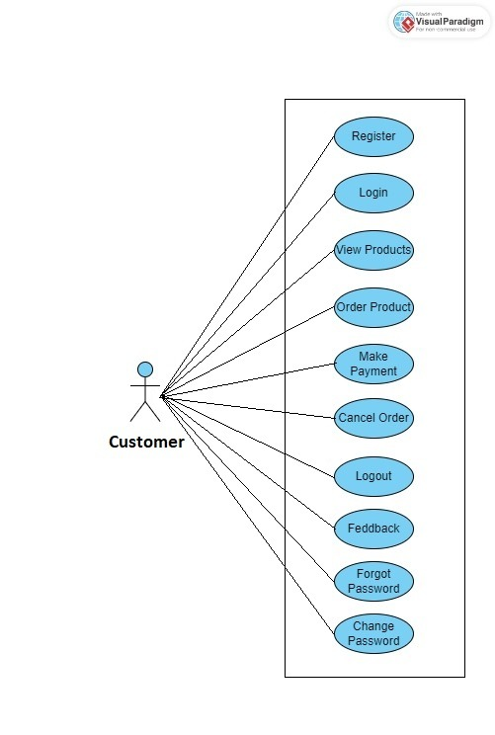

*Fig. Use case diagram for Customer*

**Cake-Vendor:**

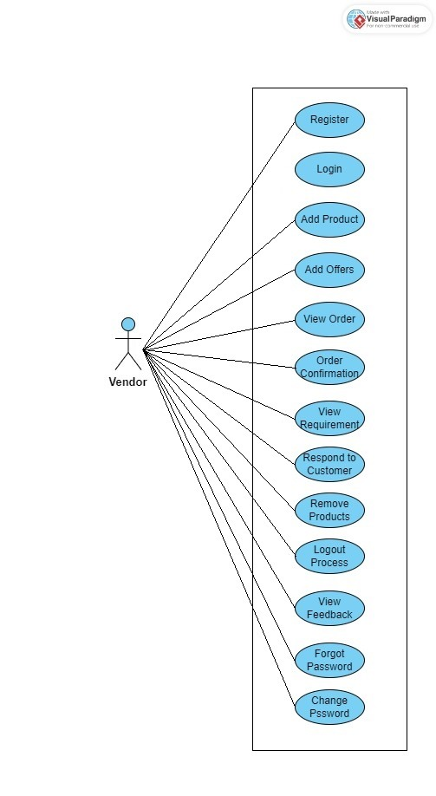

*Fig. Use case diagram for Cake Vendor*

**Admin**

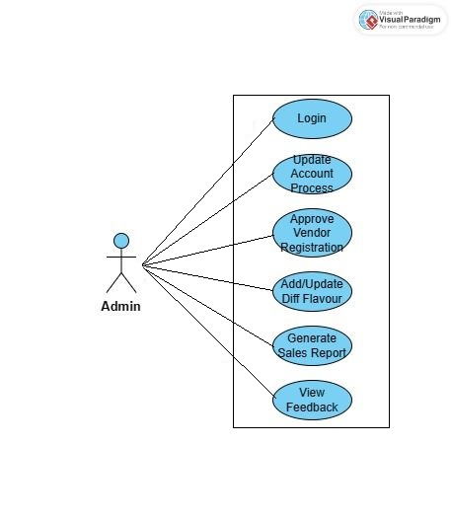

*Fig. Use case diagram for Admin*

**Corporate Customer**

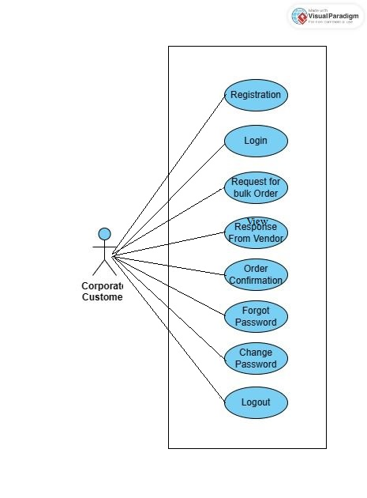

*Fig. Use case diagram for Corporate Customer*